**IHI Project ID - Acronym**

**Project Title**

**WPX – WP Title**

# D1.4 Candidate BBB targets involved in disease pathogenesis and progression

|  |  |
| --- | --- |
| **Lead contributor** | Organisation Number Cardiff |
|  |  |
| **Other contributors** | OXF |

## Document History

|  |  |  |
| --- | --- | --- |
| **Version** | **Date** | **Description** |
| V1.0 | 20 Jan 2004 |  |

## Executive Summary

Max ½ page

## Introduction

Knowledge of the gene expression patterns in different cell types within a tissue in health and disease has led to a much greater understanding of the changing cell state, identifying translational opportunities to intervene and modify. Single cell/nuclei transcriptomic sequencing, whereby the variety and abundance of mRNA types within a cell or nuclei is measured, has revolutionised our understanding of how distinct cell types within a tissue function in health and disease. While obtaining the cells of parenchymal brain tissue has been well reported, the cells that constitute the blood-brain barrier (endothelial cells, pericytes, smooth muscle cells) have been subject to much less study. Endothelial cells are universally under-represented in current human transcriptomic single-cell studies (e.g. PMID 31042697, 31768052), likely due to difficulties in freeing nuclei from robust connective tissue as opposed to the parenchyma. As reported previously, our initial microvessel-enrichment protocol yielded an endothelial cell population representing approximately 4% of all captured nuclei, which were analysed as part of a pilot project including two post-mortem brain tissue samples. Hannah Sleven from the University of Oxford (Zam Cader’s lab) significantly modified and improved the protocol with the aim to yield a higher representation of neurovascular cell types. UOXF followed up on the successful development of the Vascular/Endothelial nuclei isolation protocol in the previous reporting period with critical methodological and logistical improvements. The key additional feature of the resultant protocol, NeuroV-seq (Figure 1), is the simultaneous isolation of separate vascular and parenchymal nuclei fractions from the same starting brain tissue whilst retaining the outstanding vascular purity achieved in the initial method. Technical improvements utilised novel 3D design and printing to achieve a shorter protocol duration and higher reproducibility.

The NeuroV-seq protocol was used on a large (20 control, 20 Alzheimer’s cases) cohort to generate novel and crucial data on properties of the vasculature and parenchyma in health and disease. Tissue identification and supply and the tissue and nuclei processing was conducted by UOXF and the bioinformatic analysis by our partners in UCAR.

## Methods

An overview of the method is given in Figure 1. We identified poor removal of meningeal tissue, poor control of dissection and loss of valuable tissue mass when traditional 4⁰C dissection of brain tissue was performed. Meningeal contamination and poor dissection control was particularly detrimental to high yield vascular nuclei recovery. We developed a simple unit to enable dissection whilst maintaining tissue temperature at ~-80C outside of the freezer allowing, careful removal of meninges and other contaminants. We further created a 3D printed tissue chopper to perform rapid and precise dissection of ultra-cold frozen tissue from solid brain matter into a coarse powder optimal for nuclei isolation, which can then be stored at -80⁰C until the day of isolation. Brain vessels are typically lost in standard isolation protocols through under- or over-homogenisation. Our homogenisation procedure enables thorough release of vessels whilst minimising vessel damage. It utilises a 3D printed pestle to allow large-volume pestle-driven homogenisation. Multiple rounds of homogenisation and low speed centrifugation remove released vessels as homogenisation of tissue progresses (Fig 1B) and finally isolate incompletely homogenised tissue for Dounce homogeniser vessel release. Subsequent low-speed centrifugation steps segregate the vessels from the tissue homogenates at which point the vessel-free supernatant is removed for parenchymal isolation. The vascular pellets are then further processed for nuclei isolation. Purification of the vascular fraction begins with two multi-layer dextran gradient centrifugation steps using a standard refrigerated laboratory centrifuge. The density interfaces trap contaminants whilst allowing vascular transfer, greatly outperforming a single gradient approach. Filtering the resulting vessel suspension through a 100um nylon filter removes unwanted larger vessels, and vessel capture on 40um PET filters allows depletion of residual contaminating particles.

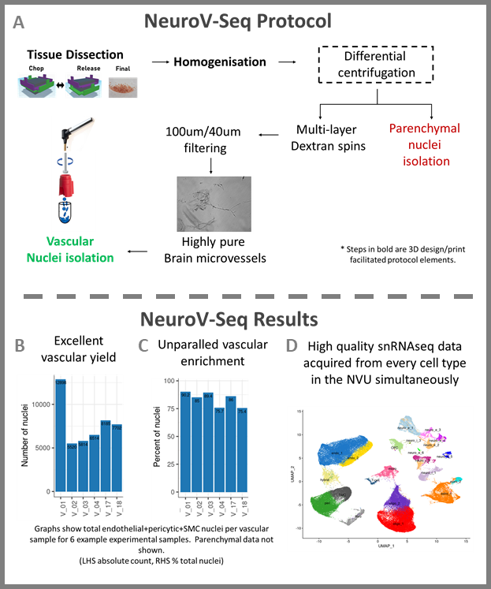**Figure 1: Overview of the NeuroV-seq protocol** (A), and example results of vascular nuclei yield (B) and enrichment (C). UMAP Plot (D) verifies capture of all the major brain cell types using NeuroV-seq protocol.

Purified vessels are then transferred onto 20um PET filters for digestion and nuclei isolation. First collagenase II digestion at 4⁰C permeabilises the basement membrane of the vasculature. After the enzyme and released final debris are removed with a wash step, the 20um filter is placed into the 3D printed funnel assembly (supp Fig x ) and a hand-held homogeniser is used with a 3D printed flat base pestle to grind the nuclei out of the vessels which are then captured by flushing through to a tube. Nuclei after staining with DAPI are isolated using FACS. The parenchymal supernatant extracted previously is processed to nuclei using standard protocols and similarly FACS isolated. Extracted and isolated nuclei can then be used with the single-nuclei RNA-seq platform of choice (here 10x Genomics) for transcriptomic analysis Our protocol provides extensive coverage of all four major vascular cell types (endothelial, pericyte, smooth muscle cell (SMC), fibroblasts) and their neighbouring parenchymal cells (astrocytes, microglia, excitatory neurons, inhibitory neurons, oligodendrocytes, oligodendrocyte precursor cells (OPC)). Additionally vascular-associated microglial populations and both vascular and parenchymal T-Cell populations are isolated during the procedure. Our vascular isolation captures the vasculature at a mean purity of 93% with a predominantly capillary population of endothelial cells and mural cells. Thus, the isolation method simultaneously captures every brain cell type and constitutes both the first high purity vascular isolation and the first high-yield whole-brain nuclear isolation protocol. For the first time it allows detailed examination of the vasculature and whole-tissue brain transcriptomics analyses.

FastQC/MultiQC were run to assess sequencing quality, no issues were found with the latest batch of samples. Subsequently standard processing was done with cellranger, using an updated reference with Ensembl version 109 and Gencode version 43. The output of this was run through scFlow with standard parameters which was then read into R via the Seurat package.The read counts and number of features output from scFlow revealed that 3 of the donors, and the vascular fraction from a fourth donor, were of poor quality and so they were excluded from downstream analysis. The final set of nuclei showed highly comparable reads and gene counts per nuclei were obtained from both parenchymal and vascular fractions and between AD cases and controls (**Figure 2**). PCA was performed and 35 dimensions were used to find nearest-neighbors and a resolution of 0.6 was used to find clusters via Seurat. UMAP was computed with the same 35 dimensions. Cluster markers were found using genes with at least 20% of cells in a cluster expressing them, and a minimum log foldchange of 0.5, again via Seurat (**Figure 3**).

Differences in cell type proportions between cases and controls were examined with the speckle R package. It leverages biological replication to obtain measures of variability of cell type proportion estimates and uses empirical Bayes to stabilize variance estimates by borrowing information across cell types.



Figure 2: Mapped reads (right) and gene counts (left) per nuclei are highly similar between both the parenchymal and vascular nuclei fractions and between AD cases (red) and controls (green).

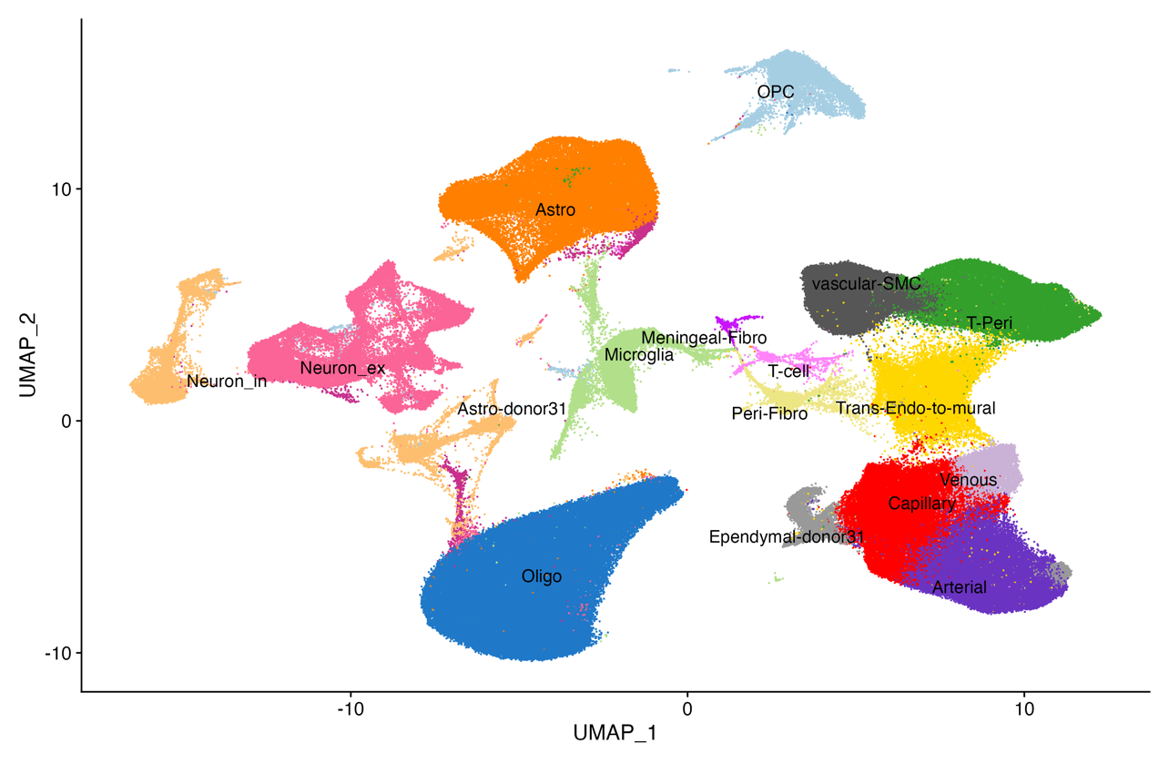**Figure 3:** A UMAP of the sequencing data with manual annotations of cell types. Note that there are more granular subtype annotations in Figure 4 that are not shown here in the interest of visual clarity.

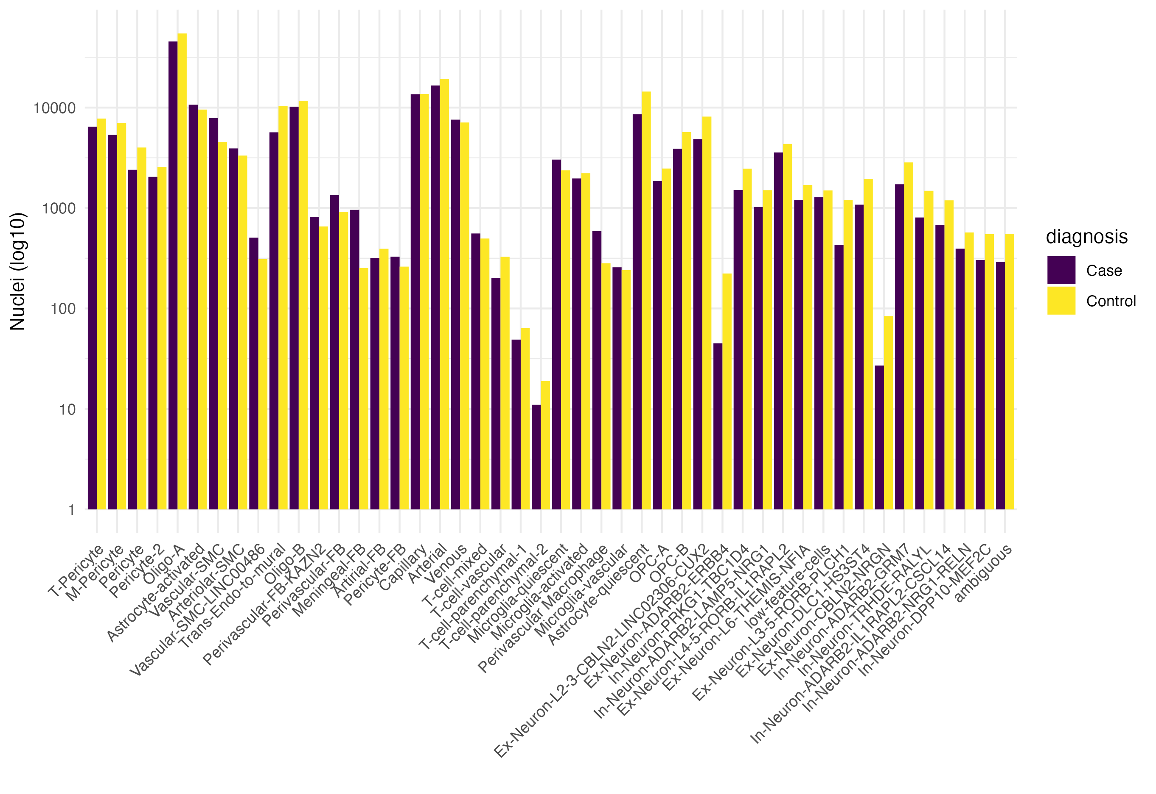

Figure 4: Nuclei counts per cell-type for AD and control groups.

## Results

We received the single nuclei sequencing and genotype data for the final 20 donors in 2023 for this project, bringing the total to 40 donors (20 cases/ 20 controls), each with separate parenchymal and vascular fractions separately for a total of 80 samples sequenced. All data has been reprocessed with updated reference genomes to maintain consistency across all three sequencing batches. Three donors and the vascular fraction of a fourth donor did not pass QC checks and so were excluded. The cell types (both high level and subtypes) were then manually annotated based on cluster markers and concordance with existing literature, though no other papers have gotten a comparable level of enrichment for these cell types (Figure 3) (Yang et al. 2022).

**The role of the brain vasculature in the risk of Alzheimer’s disease**

To address the question of the role of vascular and parenchymal cell types in the manifesting the genetic risk of AD, we used a classical analyses examining the location of cell type-specific genes within regions of the genome associated with the genetic risk of AD. Defining cell type-specifically expressed genes requires a knowledge of which genes are expressed to what level across different cell types, and thus is completely dependent upon the range of cell types considered. Our novel approach to obtaining vascular and parenchymal cells from the same brain tissue enables the most complete picture of cell type expression of genes within the human prefrontal cortex and thus the most accurate picture of cell type specificity. Using only nuclei from control samples, every gene was assigned a cell type specificity for each of the 43 defined cell types defined as the p-value from a Wilcoxon rank sum test p-value calculated for that gene’s expressions in a specified cell type against that genes expression across all other cell types. Genes were then ranked for each cell type and the top 5% of genes in each ranking used to define the set of cell type-specific genes for that cell type. Each set of cell -type specific genes was then examined using MAGMA for an association with Alzheimer’s disease risk, where Alzheimer’s disease risk was defined using summary p-values derived from (Bellenguez et al. 2022) (**Figure X**). We repeated defining cell type specificity considering only 19 vascular-fraction cell types and also considering only the 22 parencymal cell types. The results show that the method of defining the window size around AD risk loci play a critical role in defining the disease association. When cell type specificity across all cell types is considered, there is a significant association between AD genetic risk loci and genes expressed specifically in Arteriolar smooth muscle cells or in perivascular cells (**Figure 5**). However, genetic risk variants may lie within regulatory elements for genes nearby and thus sequence upstream and downstream of a gene which is likely to contain regulatory sequence for that gene is often also considered as part of that gene. When this additional sequence is included, there is a clear association specifically with genes specifically expressed in activated microglia (**Figure 5**). However, the AD risk cell type associations differ when considering only parenchymal cell types. Irrespective of the definition of the gene sequence, genes specifically expressed in quiescent microglia are associated with the genetic risk of AD. When considering only the vascular cell types when defining cell type specificity, none of the vascular cell types are significantly associated with AD genetic risk (**Figure 5**). These results illustrate that these genetic risk/cell type associations are dependent upon (i) the statistical definitions of cell type specificity, (ii) the sequence defined as associated with a given gene and (iii) the cell types used in defining cell type specificity. The exact gene networks underlying the associations detected need to be further elucidated but we note that several studies using less complete data sets have significantly associated microglia specific gene expression with AD genetic risk.



Table 1: Gene expression changes between AD and controls across cell types.

**Changes in the brain vascular in the progression of Alzheimer’s disease.**

We next turned to examine changes in the prefrontal cortex vasculature during Alzheimer’s disease. Examining the 20 cases and 20 controls who prefrontal cortex tissue had been sequenced, we looked for changes in the proportions of the cell types identified in each fraction. Across all cell types, we found only 3 that had significant changes in proportion with Alzheimer’s. In the parenchymal fraction, we identified a decrease in two populations, the *Ex-Neuron-ADARB2-ERBB4* and the *Ex-Neuron-L3 5-RORB-PLCH1* excitatory neurons (**Figure 6**). The loss of these two neuronal subtypes in Alzheimer’s disease matches previously published analyses reporting the loss of these two neuronal populations, corroborating our single cell approach here (REF). In the vascular fraction, we found only a decrease in the *Trans Endo-to-Mural* population in Alzheimer’s disease (**Figure 6**). There is little known about this cell type in the neurovasculature but the gene markers of this cell population match those of mouse endocardial endothelial cells which are reported to be progenitors of pericytes and vascular smooth muscle cells in the murine embryonic heart (Chen et al. 2016). In the mouse, endocardial cells undergo endothelial–mesenchymal transition and convert into primitive mesenchymal progenitors that migrate into the myocardium, differentiate and assemble the wall of coronary vessels. Assuming the role in the mouse myocardium are maintained in the human neurovascular, the apparent decrease of the *Trans Endo-to-Mural* population in Alzheimer’s disease could indicate deficits in the maintenance of the brain’s blood vessels.

We next turned to examine the changes in gene expression in each cell type. For this, we grouped the 43 cell types (**Figure 4**) into their overarching cell classifications and looked for changes in gene expression. While we observed a large number of differentially expressed (DE) genes within the parenchymal populations, most notably amongst astrocytes, we found more modest changes amongst three neurovascular cell types, namely endothelial cells (18 DE genes), pericytes (76 DE genes) and Trans Endo-to-Mural cells (28 DE genes) (**Table 1**). In order to examine the underlying functions associated with these genes, we identified significantly enriched Gene Ontology terms for each vascular DE gene set (**Figure 7**). The upregulated DE genes in the pericytes are enriched in vascular development. Drawing again from the mouse cardiovascular studies, pericytes form the progenitors for artery smooth muscle (Volz et al. 2015) and thus this expression may indicate the instigation of neurovascular repair processes, which fits with our observed changes in the Trans Endo-to-Mural cell population described above. Both the endothelial cells and the Trans Endo-to-Mural cell population upregulate genes involved in the cellular response to peptide hormones….. All three cellular populations downregulate genes associated with tRNA processing which suggests an increase in translational regulation in these cells during Alzheimer’s.

**Changes in IM2PACT candidate blood-brain-barrier transporters during Alzheimer’s disease.**

For Deliverable 1.X, by combining unpublished endothelial data produced by the IMI COMPACT with single cell mouse RNAseq data from the Betzholts group and refining through functional genomics, we identified 9 candidate transporters, namely APCDD1, ATP10A, ELOVL7, LRRN3, PROM1, SEMA7A, SLC16A4, SLC3A2 and SLC7A1. Of these, pilot human neurovascular singled out ATP10A, ELOVL7 and SLC7A1 as being specifically expressed in neurovascular cell types (**Figure 8**) and thus became the subject of further investigations by the IM2PACT consortium efforts. The utility of these candidate transporters for delivery of any therapeutic agent for AD could be severely affected by the transporter’s expression during AD and the availability of our larger set of controls along with AD cases enabled us to examine the expression of ATP10A, ELOVL7 and SLC7A1 during the disease. Expression analyses of these three candidate transporters revealed that their expression was largely unaltered in the Alzheimer’s cases as compared to controls (**Figure 9**) and thus they remain attractive candidate transporters for AD therapeutics.

Figure 5. Heatmap of -log10 adjusted p-values of celltype associations with Alzheimer’s disease risk. Derived from MAGMA scores using the Bellenguez et al. 2022 GWAS summary statistics, both with APOE and without the APOE region. Celltype gene lists were created for all control nuclei, the control parenchymal nuclei and the control vascular nuclei fractions seperately. The SNP-gene annoation was perfomed with and without a 35/10 kilobase window around the gene.

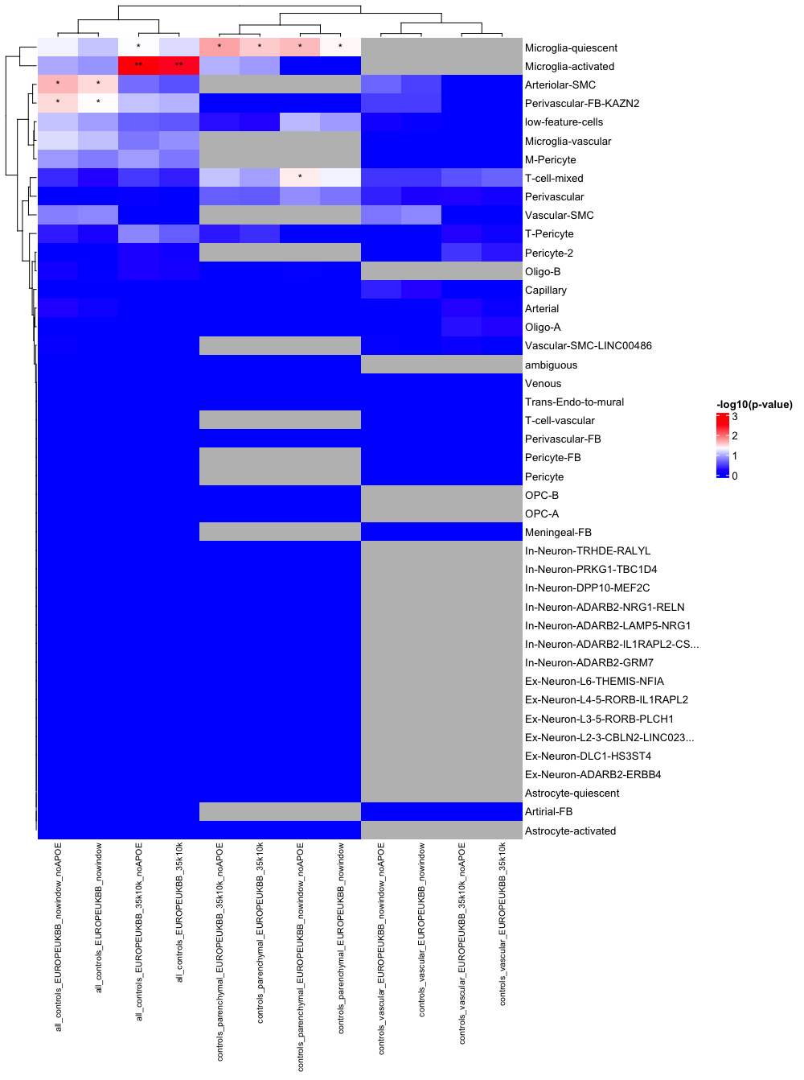

Figure 5.

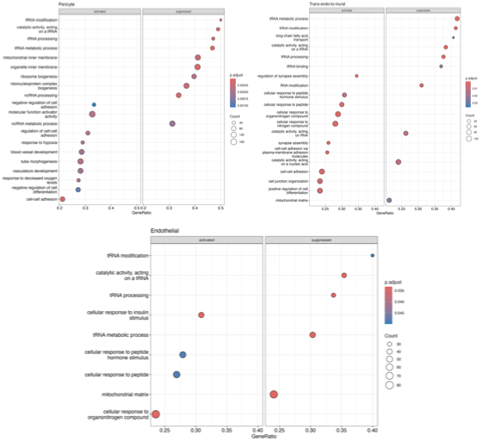

Figure 7:



Figure 6: Significant differences in proportions were observed between only 3/43 cell types between AD (case) and controls, specifically for the Trans Endo-to-Mural cells within the vascular fraction and for two types of excitatory neurons within the parenchymal fraction. Speckle R package, p adj < 0.05.

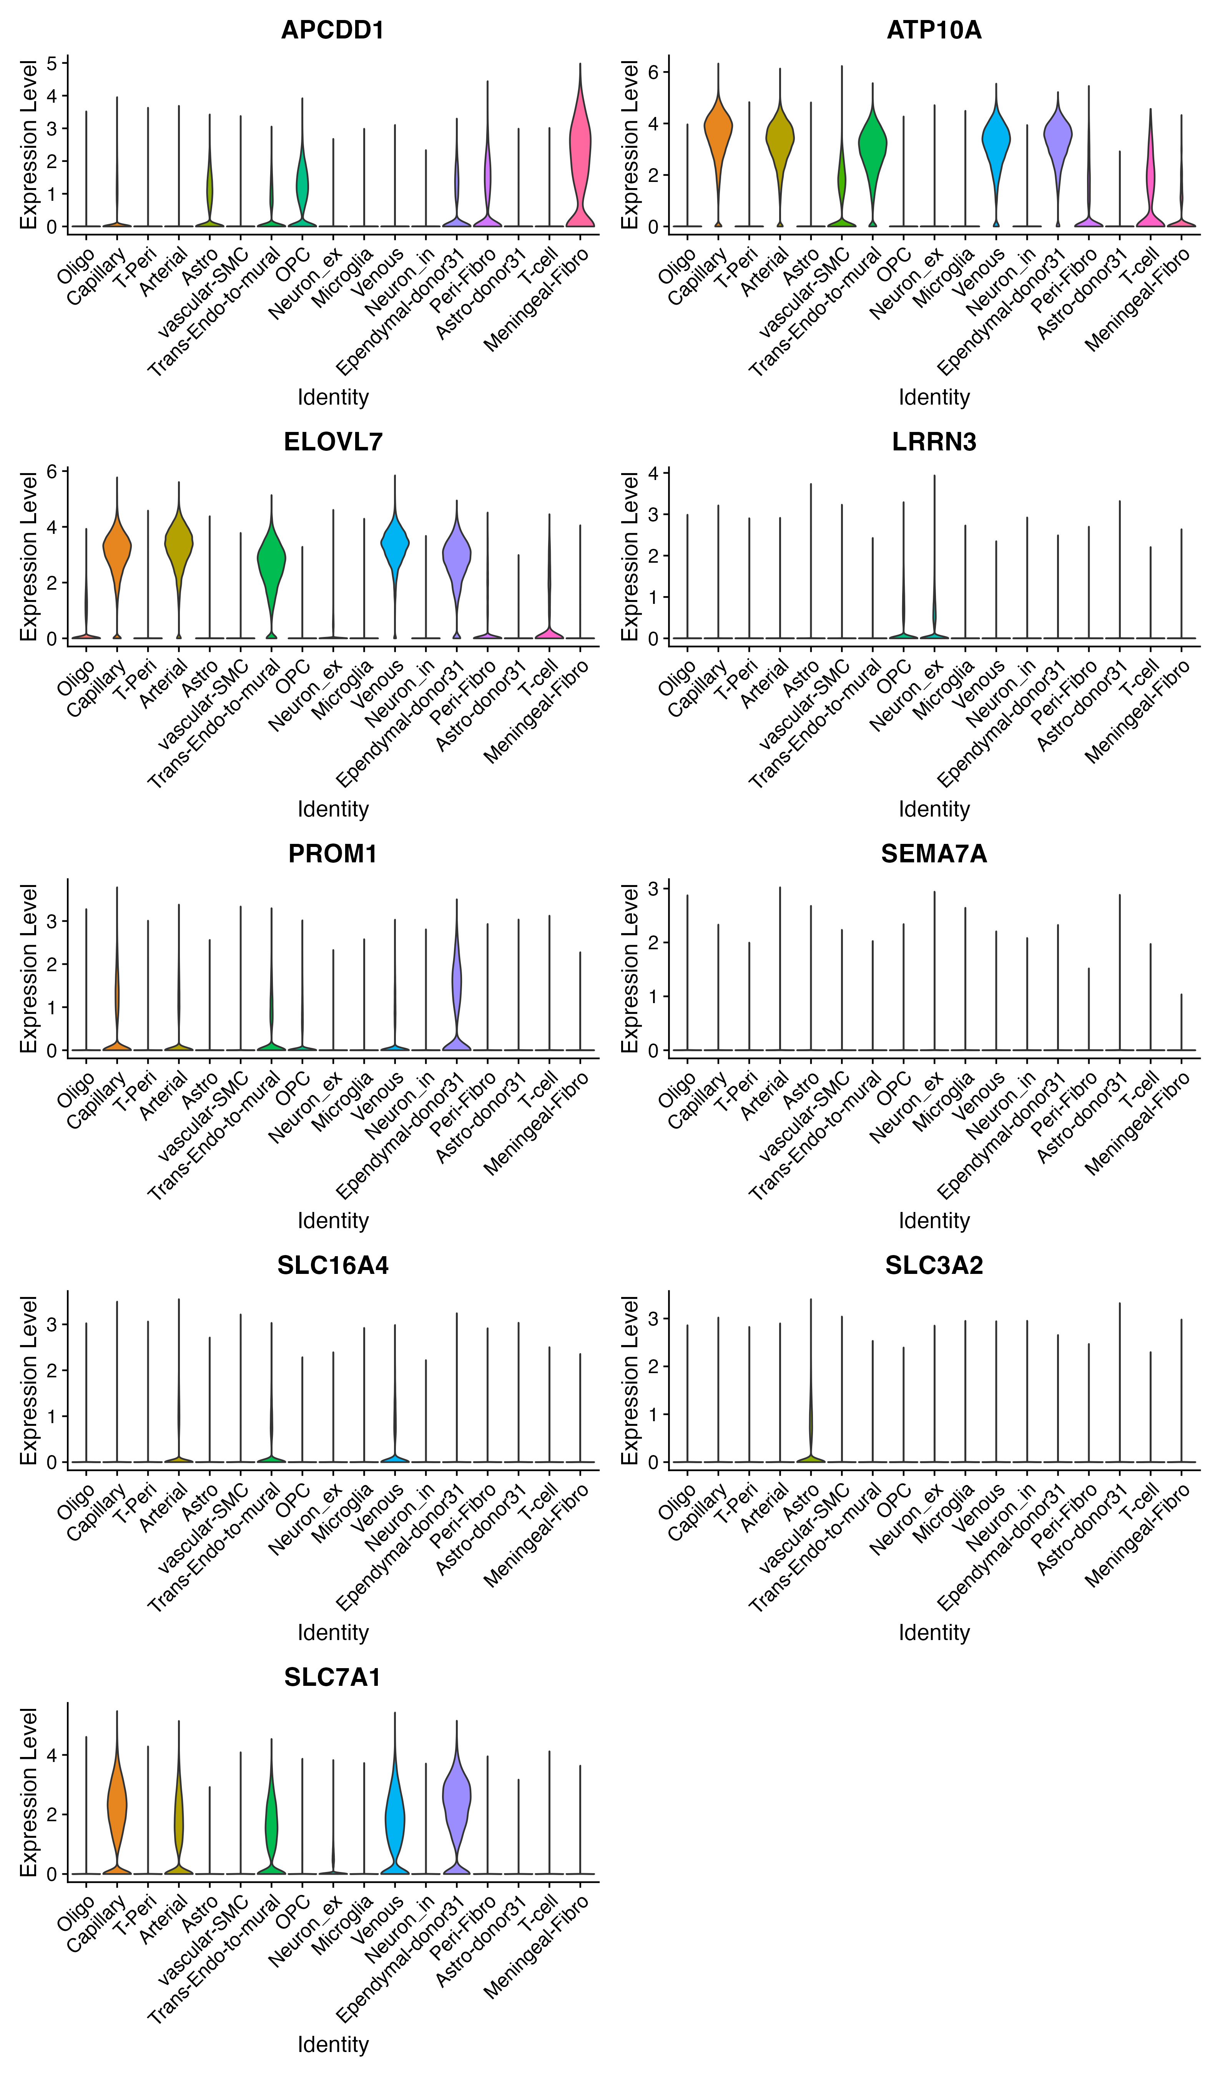

**Figure 8: Expression profile of candidate blood brain barrier transporters across cell types.**

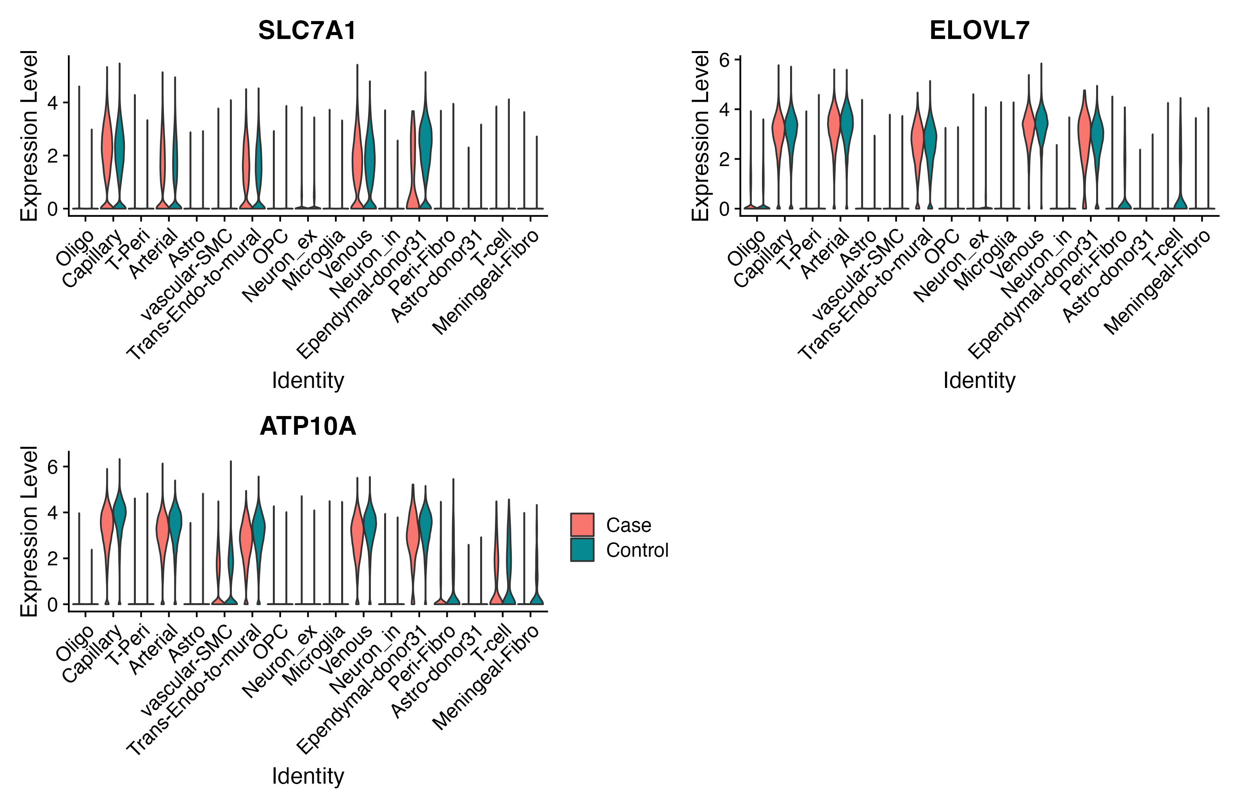**Figure 9: Expression profile of promising candidate blood brain barrier transporters in level 1 cell types across cases and controls.**

## Discussion

## Conclusion

## Repository for primary data

Bellenguez, Céline, Fahri Küçükali, Iris E. Jansen, Luca Kleineidam, Sonia Moreno-Grau, Najaf Amin, Adam C. Naj, et al. 2022. ‘New Insights into the Genetic Etiology of Alzheimer’s Disease and Related Dementias’. *Nature Genetics* 54 (4): 412–36. https://doi.org/10.1038/s41588-022-01024-z.

Chen, Qi, Hui Zhang, Yang Liu, Susanne Adams, Hanna Eilken, Martin Stehling, Monica Corada, Elisabetta Dejana, Bin Zhou, and Ralf H. Adams. 2016. ‘Endothelial Cells Are Progenitors of Cardiac Pericytes and Vascular Smooth Muscle Cells’. *Nature Communications* 7 (1): 12422. https://doi.org/10.1038/ncomms12422.

Volz, Katharina S., Andrew H. Jacobs, Heidi I. Chen, Aruna Poduri, Andrew S. McKay, Daniel P. Riordan, Natalie Kofler, Jan Kitajewski, Irving Weissman, and Kristy Red-Horse. 2015. ‘Pericytes Are Progenitors for Coronary Artery Smooth Muscle’. *eLife* 4 (October): e10036. https://doi.org/10.7554/eLife.10036.

Yang, Andrew C., Ryan T. Vest, Fabian Kern, Davis P. Lee, Maayan Agam, Christina A. Maat, Patricia M. Losada, et al. 2022. ‘A Human Brain Vascular Atlas Reveals Diverse Mediators of Alzheimer’s Risk’. *Nature* 603 (7903): 885–92. https://doi.org/10.1038/s41586-021-04369-3.